Operation Manual
HM-TYDGZ-500kVA
3-phase Inductive Voltage Regulator

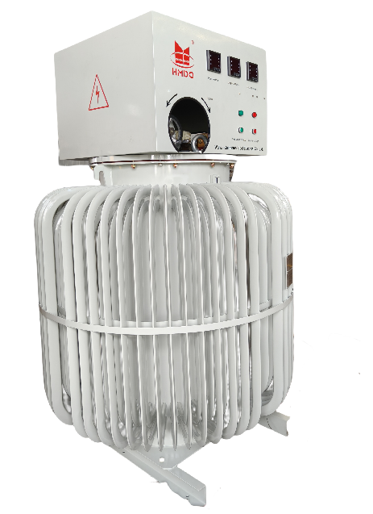

WUHAN GOLDHOME HIPOT ELECTRICAL CO.,LTD
Tel.：+86-13720185294 Fax：+86-27-84620387
Email: goldhome02@cablehipot.com Web.: www.hvcablehipot.com
Add.: No.A25-1, Huading Mould Industrial Park, Hannan, Wuhan, Hubei, China

1.Basic Principles and Applications
Oil-immersed induction voltage regulators feature contactless regulation, extended service life, and robust overload capacity, making them suitable for diverse load types. These regulators enable stepless, smooth, and continuous adjustment of output voltage under load conditions. Primary applications include: motor testing, transformer testing, generator excitation, and electric furnace temperature control. They find extensive use across mechanical engineering, power generation, chemical processing, telecommunications, and metallurgical industries.

2.Working Conditions
Under the following conditions, this product can operate continuously for a long time:
(1). Altitude does not exceed 3000 meters
(2). Ambient medium temperature is not higher than +40°C and not lower than -25°C
(3). Relative air humidity not exceeding 85%
(4). Environment free of chemically corrosive gases and vapors
(5). Absence of explosive gases
(6). Temperature rise standards for this product: Oil surface temperature rise 55°C (when ambient temperature is 40°C, maximum oil surface temperature must not exceed 95°C), winding temperature rise 65°C, silicon steel sheet temperature rise 80°C.

3. Meaning of Model

The meaning of the voltage regulator model is as follows:

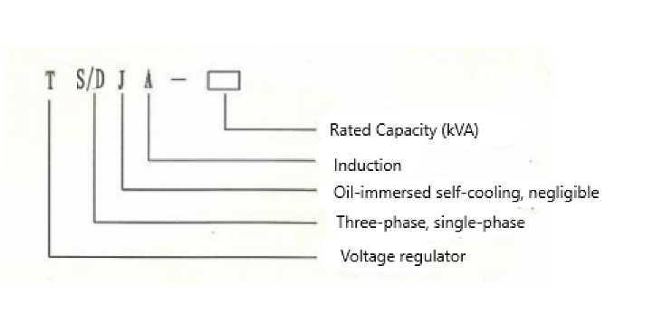

4. Technical Specifications
- Capacity Range: 500KVA
- Input Voltage: 400V
- Output Voltage: 0~800V
- Frequency: 60Hz
- Efficiency: 96%
- Voltage control band: 5~10V
- Work duration ：Within 8 hours at 100% rated output.
Long-term continuous operation at 80% output
- Dielectric Strength: 2000V / 60S < 10mA
- Insulation Resistance: >20MΩ
- Ambient Temperature: -25℃ to +40℃
- Relative Humidity: <95%
- Temperature Rise: <55℃
- Noise Level: <85dB

5.Working Principle
This product features a structure similar to a typical vertical-wound rotor asynchronous motor. Since it operates in a locked-rotor state, its working principle resembles that of an induction motor and transformer. A turbine transmission mechanism is installed on the voltage regulator to induce angular displacement of the rotor or apply braking to it. When the relative angular position of the rotor changes, for single-phase voltage regulators, this alters the interlinked magnetic flux between the stator and rotor windings, thereby changing the induced electromotive force in the secondary winding. For three-phase voltage regulators, it modifies the phase angle of the induced electromotive force on both the stator and rotor windings. Through a self-coupled circuit connection, this enables smooth, stepless variation of the output voltage.
1.The primary winding of a three-phase voltage regulator can be placed either in the stator or the rotor, depending on the design. The connection between the primary winding and the secondary winding is as shown in Figure 1 (a).

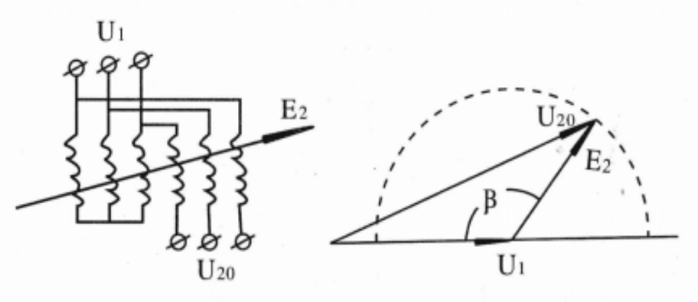
（a）Winding Connection （b）Potential and Charge Figure 1
In the diagram:
U1------Input voltage:
E2------Induced electromotive force in the secondary winding:
U20------No-load output voltage:
β------Relative angular displacement between the two windings:
When a three-phase applied voltage is applied to the primary winding, a uniform rotating magnetic field is generated in the core and air gap. This field cuts through the secondary winding at the same frequency. As the relative axial position between the rotor and stator windings changes, the magnitude of the induced electromotive force remains constant, but the phase relationship between the induced electromotive forces in the two windings shifts. The no-load output voltage is the vector sum of the primary voltage and the secondary induced electromotive force. It smoothly varies with different angular displacements (180°-β) according to the following equation.

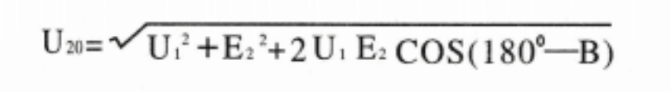
The variation curve of U20 is shown by the dashed line in Figure 1(b).In addition to the connection method shown in Figure 1, the three-phase voltage regulator can also be connected as shown in Figure2(a).
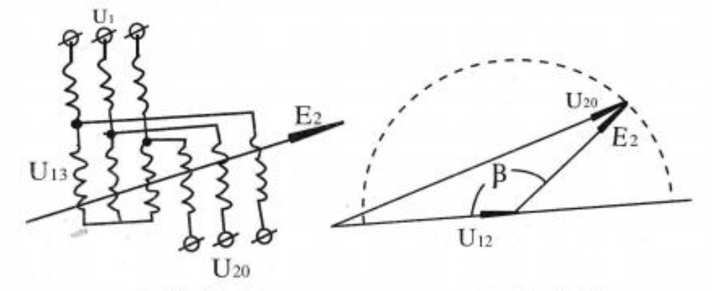
（a）Winding Connection （b）Potential and Charge

Figure2
2. The primary winding of a single-phase voltage regulator may be placed either in the stator or rotor, depending on the design. Its operating principle differs from that of a three-phase voltage regulator. The magnetic field generated in the core and air gap is pulsating rather than rotating, and it is also unevenly distributed. When the axial position between the rotor and stator windings changes, the induced electromotive force on the secondary winding varies with the differing magnetic flux, but the phase does not shift.
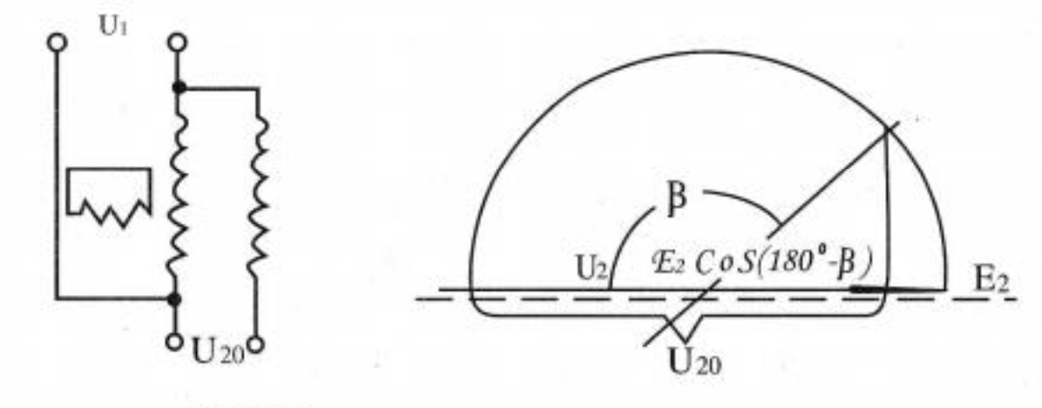
（a）Winding Connection （b）Potential and Charge

Figure3
When the winding connection is as shown in Figure 3(a), the no-load output voltage is calculated according to the following formula and changes smoothly with different angular displacements (180°-β).
U20=U1+E2CoS（180°-β）
In the equation: E₂ denotes the maximum induced electromotive force across the secondary winding.
The variation trajectory of E2 is shown by the dashed line in Figure 3(b). Alongside the primary winding is the compensation winding (also known as the short-circuit winding), which compensates for the magnetic potential generated by the load current when 0 < β < 180°, thereby reducing the significant voltage drop in the voltage regulator under load.
3. The output voltage characteristics of the voltage regulator are shown in Figure 4.
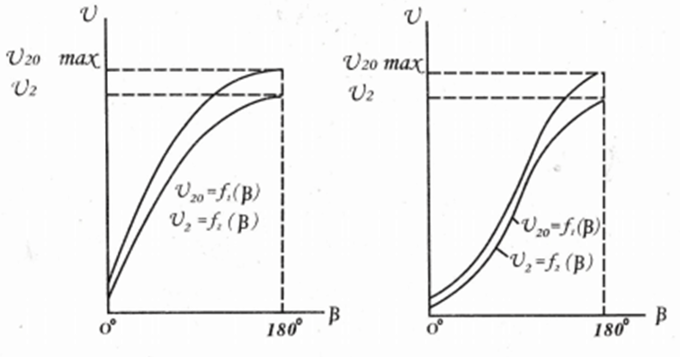（a）Three-Phase Characteristics （b）Single-Phase Characteristics

Figure4

In the figure:

f1(β)-----No-load output voltage characteristic curve:

f2(β)-----Output voltage characteristic curve under rated load impedance:

U20max-----Maximum no-load output voltage

U2-----Rated output voltage value

Due to electromagnetic and structural design constraints, the no-load lower limit voltage of a voltage regulator with load voltage adjustment starting from zero often has a relatively small initial value.
6. Structural Features
The voltage regulator primarily consists of three components: the core assembly, the cooling oil tank, and the transmission mechanism.
1. The core assembly structure is identical to that of a typical vertical-type wound-rotor asynchronous generator, comprising the stator, rotor, core, windings, end plates, and base.
2. The cooling oil tank structure is fundamentally identical to that of a standard power transformer. An oil level gauge and drain valve are mounted on the tank wall, while the oil filler is located on the regulator's front panel.
3. The transmission mechanism employs a dual-purpose (manual/electric) worm gear and reduction gear. Manual/electric mode switching is achieved via a claw-type clutch. Pushing the handwheel on the large worm gear inward engages electric operation, while pulling it outward engages manual operation. The rotor shaft end features a 180° sector-shaped worm gear, typically connected to the rotor shaft via a shear pin. During transformer load short circuits, the shear pin shears off, preventing damage to the reduction gear. The regulator panel features minimum/maximum travel switches and mechanical limiters. Travel switches automatically cut motor power when output voltage reaches upper/lower limits. Mechanical limiters restrict rotor rotation to specified angles, preventing winding lead breakage and cushioning impacts to avoid violent rotor collisions.
4. The voltage regulator's input terminal is labeled with A, B, C (three-phase) or A, X (single-phase). The output terminal is labeled with a, b, c (three-phase) or x, a (single-phase), facilitating proper wiring installation.

7. Installation, Operation, Maintenance
1. The transformer base must be properly grounded to ensure safety.
2. Sufficient space should be maintained around the transformer for ventilation, heat dissipation, and maintenance.
3. For newly installed or long-unused voltage regulators, measure the insulation resistance between windings and ground using a megohmmeter. A value of no less than 1 megohm is required for safe operation. Otherwise, perform heating treatment using either the energized drying method or by removing the core and drying it in a drying chamber.
4. Perform the following checks before operation:
(1) Verify the rated input voltage on the nameplate matches the power supply voltage. Ensure the rated load voltage adjustment range aligns with operational requirements.
(2) During manual adjustment, the transmission mechanism must rotate smoothly with consistent resistance throughout the adjustment process.
(3) During electric adjustment, the servo motor's rotation direction must match the “Increase Voltage” or “Decrease Voltage” indicator on the regulator. If mismatched, swap any two input wires of the servo motor. When load voltage reaches upper/lower limits, limit switches should activate to stop the servo motor. Otherwise, reverse the wiring of the highest and lowest limit switches.
5. When adjusting the voltage regulator under load, gradually increase the load voltage from the lower limit to the required value to prevent impact phenomena.
6. When the voltage regulator is in continuous operation for extended periods, the load current must not exceed the rated value. Its overload capacity permits short-term gradual overload operation as per the following table:

Load Current | 25% Overload | 50% Overload | 75% Overload | 100% Overload
Maximum  Duration | 120 mins | 60mins | 20mins | 10mins
7. If a shear pin is found broken, investigate the cause and eliminate the fault before replacing it with a shear pin of the same size and material.
8. Regularly inspect and replenish the cooling oil in the regulator.
9. Keep the regulator clean. Periodically lubricate the oil cup and ensure the worm gear meshing sections are adequately greased.
10. The primary disassembly procedure for regulator maintenance is as follows: Use lifting equipment to remove the body from the oil tank. Dismantle the transmission mechanism and front panel. Lift out the rotor assembly, then remove the stator assembly.

